**Project Development Phase**

**Model Performance Test**

|  |  |
| --- | --- |
| Date | 18 November 2022 |
| Team ID | PNT2022TMID20647 |
| Project Name | Project - **Deep Learning Fundus Image Analysis for Early Detection of Diabetic Retinopathy** |
| Maximum Marks | 10 Marks |

**Model Performance Testing:**

|  |  |  |  |
| --- | --- | --- | --- |
| **S. No:** | **Parameter** | **Values** | **Screenshot** |
| 1. | Model Summary | **Total params: 21,885,485**  **Trainable params: 1,024,005**  **Non-trainable params: 20,861,480** |  |
| 2. | Accuracy | Training Accuracy – **0.7812**    Validation Accuracy – **loss 2.3932** |  |
| 3. | Confidence Score  (Only Yolo  Projects) | Class Detected -    Confidence Score - | -------- |

**OUTPUT :**

1. Analysis of an image which shows that the person is affected by Diabetic Retinopathy

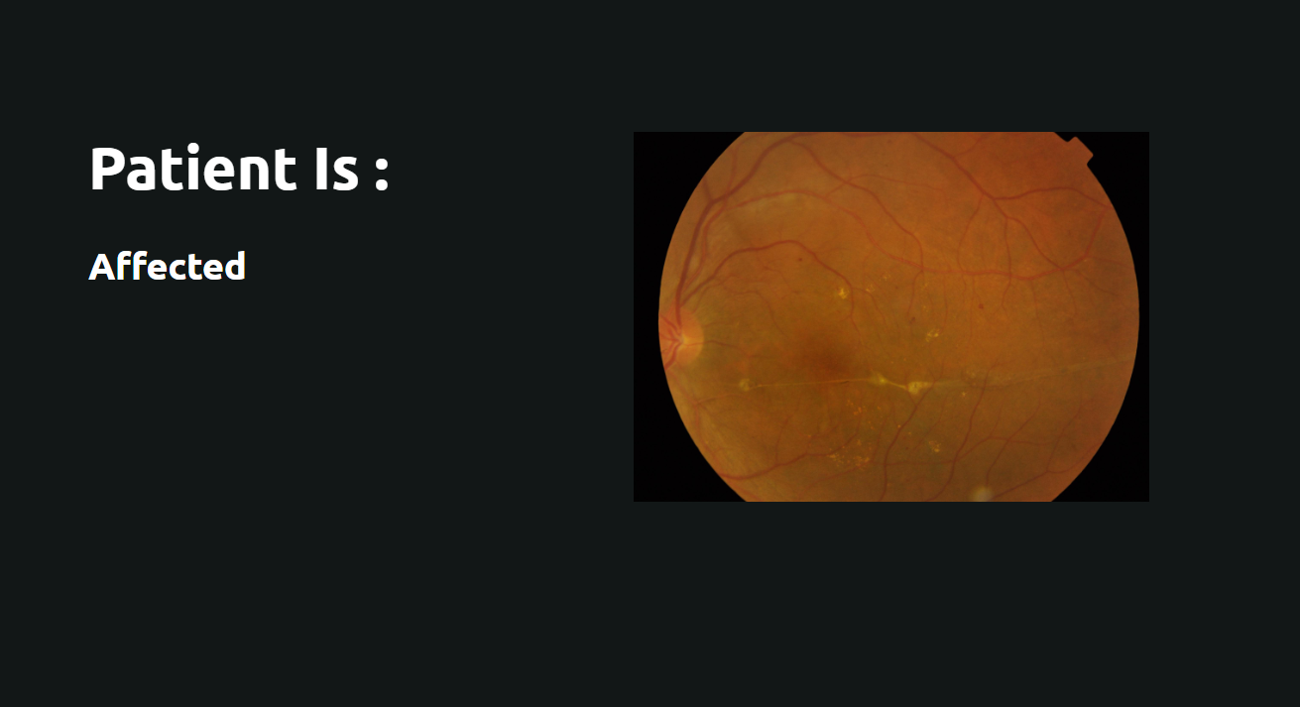

1. Analysis of an image which shows that the person is not affected by Diabetic Retinopathy

